Project Design Phase-I
Solution Architecture

Date | 31 October 2026
Team ID | NA
Project Name | Electric Vehicle Market Performance & Insights
Maximum Marks | 4 Marks

Solution Architecture:
Solution architecture is a complex process – with many sub-processes – that bridges the gap between business problems and technology solutions. Its goals are to:
- Find the best tech solution to solve existing business problems.
- Describe the structure, characteristics, behavior, and other aspects of the software to project stakeholders.
- Define features, development phases, and solution requirements.
- Provide specifications according to which the solution is defined, managed, and delivered.

Solution Architecture Diagram:
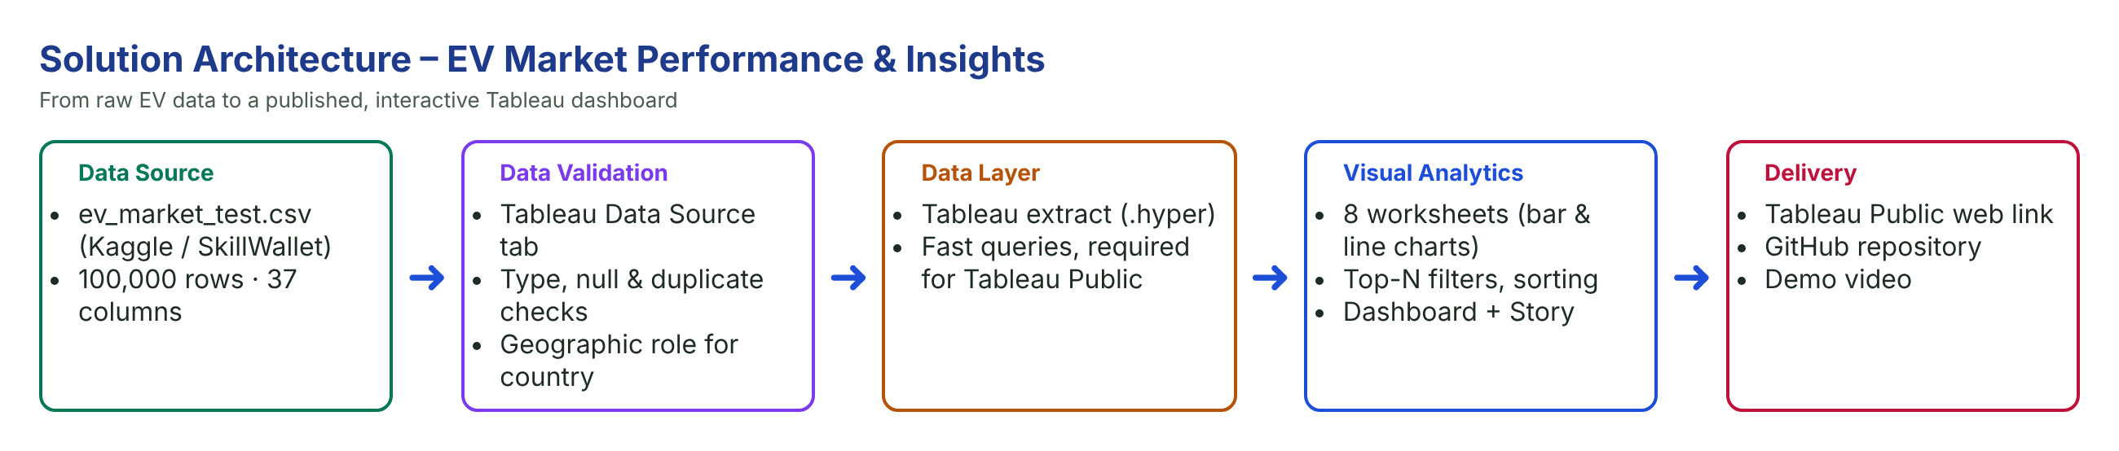

Component Description Table
Component Name | Description / Role in Architecture | Technology Used
Data Source | EV market dataset ev_market_test.csv (100,000 rows, 37 columns) | CSV (Kaggle / SkillWallet)
Data Validation | Checks data types, nulls and duplicates; sets geographic role | Tableau Data Source tab
Data Layer | Stores the data as a fast extract | Tableau extract (.hyper)
Analytics | Aggregations (SUM, AVG, COUNT), Top-10 filters, sorting | Tableau Desktop
Visualisation | 8 worksheets, dashboard with 6 charts, Story | Tableau Desktop / Public
Delivery | Public dashboard link, files and documentation, demo video | Tableau Public, GitHub, Google Drive

